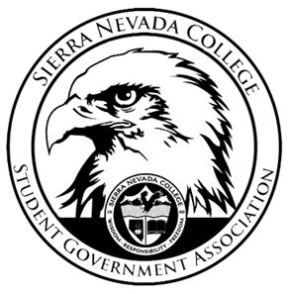
Sierra Nevada College Student Government Association

Friday, August 17th, 2018
This is an agenda for the SGA Board at
8:30 AM in Campbell Friedman - SGA Office

AGENDA

- Attendance
- Reports
  - President

  - Vice President

  - Treasurer

  - Director of Communications
    - Nothing to report
  - Sustainability Chair
  - Director of Events
  - Senators
  - Advisor
- Guests & Proposals:
  - New food and beverages rules (Nicole)
- General Business
  - Debriefs & Updates:
    - Orientation BBQ
    - 1st Catamaran trip
  - Upcoming Events:
    - Health week
    - Halloween dance
    - 2nd Catamaran trip
  - SGA
    - SGA sweaters (sizes)
    - High Altitude passes
    - Meeting time

- Last Comments
- Adjournment

SGA Executive Board: President- Ty Casey, Vice President- Matt Morgan, Treasurer- Luka Gobec
Director of Communications- Madalyn Johnson, Sustainability Chair-Lauren Rose, Director of Events-Lillian Kuehneisen,
Faculty Advisor- Will Hoida

