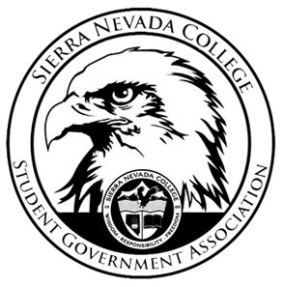
Sierra Nevada College Student Government Association

Monday, February 25, 2019
This is an agenda for the SGA Board at
8:30 AM in Campbell Friedman - SGA Office

Minutes

- Attendance
  - Open 8:34 am
- Reports
  - President
    - Ty will email chaperons for Spring Formal.
  - Vice President
    - Nothing to report
  - Treasurer
    - Could not attend meeting
  - Director of Communications
    - Nothing to report
  - Sustainability Chair
    - For the electric fence, Green Council will potentially buy parts for the bear proof composing on Amazon.
  - Director of Events
    - Could not attend meeting
  - Senators
    - Nothing to report
  - Advisor
    - Could not attend meeting
    - Alibi is having a Trivia night for Alumni and current Seniors.
    - Grand Prize will be cash
    - 6-9 pm
    - Trivia starts at 7 pm
    - This Wednesday, February 27th
- Guests & Proposals:
  - Golf Club
    - Requesting funds for weather gear, training equipment, and golf balls.
  - Climbing Club
    - Requesting funds for a climbing trip and t-shirts.
- General Business
  - Debriefs & Updates:
    - Club Trivia
      - Next year there will 80 questions next year.
    - Perspective Students Bowling Event
      - Perspective and SNC students both showed up.
      - Next year pizza should be held at the event.
  - Upcoming Events:
    - Club Dodgeball
      - Check with the Rec Centers availability
    - Spring Formal
      - April 27th 7-11 am
      - Theme ideas
  - SGA
- Last Comments
- Adjournment
  - Closed 9:24 pm

SGA Executive Board: President- Ty Casey, Vice President- Drake Fiske, Treasurer- Luka Gobec
Director of Communications- Madalyn Johnson, Sustainability Chair-Lauren Rose, Director of Events- Saana Ahonen,
Faculty Advisor- Will Hoida

