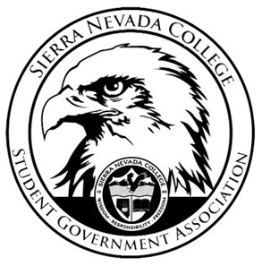
Sierra Nevada College Student Government Association

Tuesday, September 18, 2018
This is an agenda for the SGA Board at
8:00 AM in Campbell Friedman - SGA Office

Agenda

- Attendance
- Reports
  - President
  - Vice President
  - Treasurer
  - Director of Communications
  - Sustainability Chair
  - Director of Events
  - Senators
  - Advisor
- Guests & Proposals:
  - Hayden
    - Trail of Treats
  - Golf Club
- General Business
  - Debriefs & Updates:
    - AASHE
  - Upcoming Events:
    - Health Week
  - SGA
    - VP Elections
- Last Comments
- Adjournment

SGA Executive Board: President- Ty Casey, Vice President, Treasurer- Luka Gobec
Director of Communications- Madalyn Johnson, Sustainability Chair-Lauren Rose, Director of Events-Lillian Kuehneisen,
Faculty Advisor- Will Hoida

