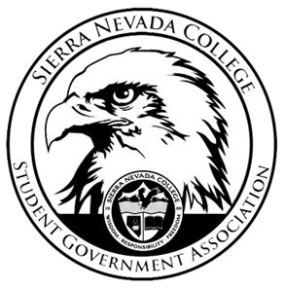
Sierra Nevada College Student Government Association

Monday, February 11, 2019
This is an agenda for the SGA Board at
8:30 AM in Campbell Friedman - SGA Office

Minutes

- Attendance
  - Open 8:31 am
- Reports
  - President
    - Dejaneri needs to sign forms to get paid for Halloween Dance.
    - The women’s lacrosse club was reimbursement for apparel.
  - Vice President
    - ICC meeting is this Wednesday at 6:30 pm, if a snow day is present the meeting will be rescheduled.
  - Treasurer
    - A finical meeting will be held next week.
  - Director of Communications
    - All photos from Casino Night have been posted on the SGA Facebook.
  - Sustainability Chair
    - Nothing to report
  - Director of Events
    - April 3rd 11-4 pm- Blood Drive event
  - Senators
    - Nothing to report
  - Advisor
    - Nothing to report
- Guests & Proposals:
  - Bryant- Admissions Event
    - February 22nd
    - Bowling with perspective students
    - Wear SNC apparel to event and bowl for free
    - $300 approved for bowling on February 22nd
  - Culture Club
    - Motion to approve $200 for a cultural dinner
    - Money will come out of club account
    - Approved
- General Business
  - Debriefs & Updates:
    - Casino Night
      - POW was the most voted charity, the money will go to the charity
      - Alumni will be invited next year
  - Upcoming Events:
    - Spring Formal
      - April 27th
      - Ty will email chaperons invitations for Spring Formal.
      - 7-11pm
    - Dating Game
      - One of the RA’s might be able to scoop ice cream
      - February 14th
    - Club Trivia
      - Drake has come up with questions.
      - TCES 106
      - 7-8:30
      - February 21st
    - Alumni & Senior Trivia
      - Senators will put up flyers.
      - 6-9 pm
      - T’s will be catered
      - This event will be at Alibi
      - February 27th
    - Northstar Ice Skating
      - March 8th
      - S’mores
  - SGA
- Last Comments
  - $200 SNC Marketing- Approved
- Adjournment
  - Closed 9:50 am

SGA Executive Board: President- Ty Casey, Vice President- Drake Fiske, Treasurer- Luka Gobec
Director of Communications- Madalyn Johnson, Sustainability Chair-Lauren Rose, Director of Events- Saana Ahonen,
Faculty Advisor- Will Hoida

