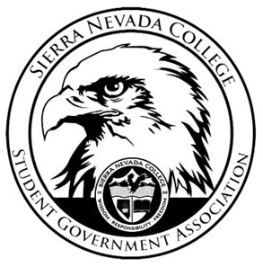
Sierra Nevada College
Student Government Association

Tuesday, October 9, 2018
This is an agenda for the SGA Board at
8:00 AM in Campbell Friedman - SGA Office

Agenda

- Attendance
- Reports
  - President
  - Vice President
  - Treasurer
  - Director of Communications
  - Sustainability Chair
  - Director of Events
  - Senators
  - Advisor
- Guests & Proposals:
  - Free Ride Club
- General Business
  - Debriefs & Updates:
    - ASSHE
    - SNC Sign
  - Upcoming Events:
    - Halloween dance
    - Ski movie night
    - Gingerbread House Decorating
    - Event survey
  - SGA
    - Evaluation
- Last Comments
- Adjournment

SGA Executive Board: President- Ty Casey, Vice President- Drake Fiske, Treasurer- Luka Gobec
Director of Communications- Madalyn Johnson, Sustainability Chair-Lauren Rose, Director of Events- Saana Ahonen,
Faculty Advisor- Will Hoida

