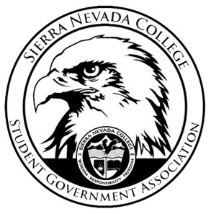
Sierra Nevada College Student Government Association

Tuesday, August 28th, 2018
This is an agenda for the SGA Board at
8:00 AM in Campbell Friedman - SGA Office

Minutes

- Attendance
  - Open 8:01 am
- Reports
  - President
    - Catamaran trip went well
      - Boat was not filled
      - Next time bring $5 to tip the waiters
    - High Altitude passes
      - 14 people are on the waitlist

  - Vice President
    - Matt Morgan was absent at the beginning of this meeting
  - Treasurer
    - 2nd deposit for Hyatt did not go through yet
  - Director of Communications
    - Annamarie in campus store, talk to her about W9 and SGA apparel
    - Potty press limit only 1 or 2 per bathroom
  - Sustainability Chair
    - 1st Green Council meeting Thursday 30th 11:45-12:45
  - Director of Events
    - High Altitude passes went smoothly
  - Senators
    - Dead line on September 7th by 5:00pm to Wil
  - Advisor
    - Tour de Tahoe
    - Tuesday morning meetings are the sometime as faculty meetings
- Guests & Proposals:
- General Business
  - Debriefs & Updates:
  - Upcoming Events:
    - Club field day
      - Club packets are due on September 3rd turn in 5:00 pm
      - Ty and Matt will meet on Thursday to discuss events for Club field day.
    - AASHE
      - 4 people
      - Conference
      - October 2nd-5th
      - Composting on campus
      - Conference will take place in Philadelphia
    - Health week
      - Lillian has contact many of the applicants
      - Table to vote on health week
    - Halloween dance
      - Events meeting
      - Wants to order the invitations
      - Dj budget
    - Events meeting
      - Thursday Time will be decided
    - Club
      - Recruit for club 12-2, grab a table to promote your club
    - Matt will talk to registrar about how to drop a class
    - Blow up Movie Screen
      - Approved $500
      - September 7th
      - Onesie theme
  - SGA
    - High Altitude passes update
      - Updating Contract for the extra 35 passes
    - Budget

- Last Comments
- Adjournment
  - Meeting close at 9:21am

SGA Executive Board: President- Ty Casey, Vice President- Matt Morgan, Treasurer- Luka Gobec
Director of Communications- Madalyn Johnson, Sustainability Chair-Lauren Rose, Director of Events-Lillian Kuehneisen,
Faculty Advisor- Will Hoida

