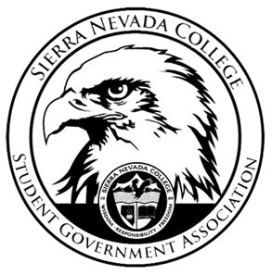
Sierra Nevada College Student Government Association

Tuesday, September 4, 2018
This is an agenda for the SGA Board at
8:00 AM in Campbell Friedman - SGA Office

Minutes

- Attendance
  - Open at 8:06 am
- Reports
  - President
    - Matt Resigned from Vice President
  - Vice President
  - Treasurer
  - Director of Communications
    - Send bio for website by Friday
  - Sustainability Chair
  - Director of Events
  - Senators
    - Packets due September 7th
  - Advisor
- Guests & Proposals:
- General Business
  - Debriefs & Updates:
  - Upcoming Events:
    - Club field day
      - Ty will be buying supplies
      - Friday September 7th 1-3pm
      - This event is taking place in Patterson Lawn
    - ICC meeting
      - Club packets deadline is extended today, packets due at 5:00pm to Will Hodia office.
  - SGA
    - HAF Passes
        - 6:30pm passes being sold tomorrow September 5th in Patterson Lobby
      - Coaches options
        - We still need to get agreement from

    - Executive board
    - AASHE
      - SGA approved $3,000 for Green Council. SGA will be donating $1,000-approved
- Last Comments
- Adjournment
  - Closed 9:12

SGA Executive Board: President- Ty Casey, Vice President, Treasurer- Luka Gobec
Director of Communications- Madalyn Johnson, Sustainability Chair-Lauren Rose, Director of Events-Lillian Kuehneisen,
Faculty Advisor- Will Hoida

