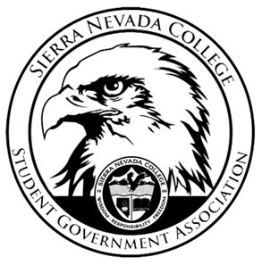
Sierra Nevada College Student Government Association

Tuesday, January 22, 2019
This is an agenda for the SGA Board at
8:00 AM in Campbell Friedman - SGA Office

Agenda

- Attendance
- Reports
  - President
  - Vice President
  - Treasurer
  - Director of Communications
  - Sustainability Chair
  - Director of Events
  - Senators
  - Advisor
- Guests & Proposals:
- General Business
  - Debriefs & Updates:
    - Gym Passes
  - Upcoming Events:
    - Casino Night
    - Boreal Friday’s
    - Club Events
    - Spring Formal

  - SGA
- Last Comments
- Adjournment

SGA Executive Board: President- Ty Casey, Vice President- Drake Fiske, Treasurer- Luka Gobec
Director of Communications- Madalyn Johnson, Sustainability Chair-Lauren Rose, Director of Events- Saana Ahonen,
Faculty Advisor- Will Hoida

