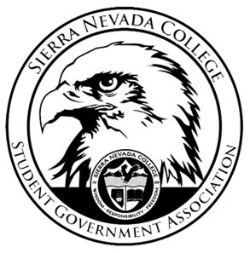
Sierra Nevada College Student Government Association

Tuesday, February 19, 2019
This is an agenda for the SGA Board at
8:30 AM in Campbell Friedman - SGA Office

Minutes

- Attendance
  - Open 8:31 am
- Reports
  - President
    - Nothing to report
  - Vice President
    - Drake emailed IT for Trivia Night
  - Treasurer
    - A check will go to POW (Protect Our Winters)
  - Director of Communications
    - Nothing to report
  - Sustainability Chair
    - Green Council is working on an electric fence for composing to make it bear proof.
  - Director of Events
    - Nothing to report
  - Senators
    - Ronan and Jośe will put The Potty Press today.
  - Advisor
    - Will could not attend today’s meeting.
- Guests & Proposals:
- General Business
  - Debriefs & Updates:
  - Upcoming Events:
    - Club Trivia
      - Thursday 7-8:30 pm
      - Drake will explain the rules to clubs at the ICC Meeting.
    - Bowling Event
      - Perspective Students
      - 4-6 pm
      - Signups will be in Patterson Lobby today
    - Spring Formal
      - Ty will write out invites for chaperons.
  - SGA
- Last Comments
  - New Calendar Forum
    - Free pizza
    - 6-7:30 pm
    - March 7th
    - TCES 106
- Adjournment
  - Closed 9:20 pm

SGA Executive Board: President- Ty Casey, Vice President- Drake Fiske, Treasurer- Luka Gobec
Director of Communications- Madalyn Johnson, Sustainability Chair-Lauren Rose, Director of Events- Saana Ahonen,
Faculty Advisor- Will Hoida

