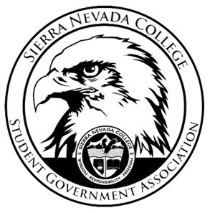
Sierra Nevada College Student Government Association

Tuesday, August 21th, 2018
This is an agenda for the SGA Board at
8:30 AM in Campbell Friedman - SGA Office

AGENDA

- Attendance
- Reports
  - President
  - Vice President
  - Treasurer
  - Director of Communications
  - Sustainability Chair
  - Director of Events
  - Senators
  - Advisor
- Guests & Proposals:
- General Business
  - Debriefs & Updates:
  - Upcoming Events:
    - Health week
    - Halloween dance
    - 2nd Catamaran trip
    - Club field day
  - SGA
    - High Altitude passes
    - Club Packets
    - Kelly Root
    - Website

- Last Comments
- Adjournment

SGA Executive Board: President- Ty Casey, Vice President- Matt Morgan, Treasurer- Luka Gobec
Director of Communications- Madalyn Johnson, Sustainability Chair-Lauren Rose, Director of Events-Lillian Kuehneisen,
Faculty Advisor- Will Hoida

