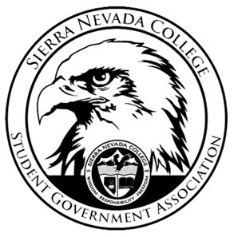
Sierra Nevada College Student Government Association

Tuesday, March 26, 2019
This is an agenda for the SGA Board at
8:30 AM in Campbell Friedman - SGA Office

Minutes

- Attendance
  - Open 8:30 am
- Reports
  - President
    - Ty updated the club packets

  - Vice President
    - Nothing to report
  - Treasurer
    - A PR needs to be made for Hyatt
  - Director of Communications
    - Nothing to report
  - Sustainability Chair
    - Lauren has the link to the POW donation from Casino Night.
    - On Earth Day, Green Council will create a trivia with prizes for winners.
  - Director of Events
    - An events meeting will be held sometime at the end of the week.
  - Senators
    - Nothing to report
  - Advisor
    - Make the student body pumped about students running for the E Board
- Guests & Proposals:
- General Business
  - Debriefs & Updates:
  - Upcoming Events:
    - Spring Formal
      - Saturday April 27th 7-11 pm
      - Saana, Ty and Luka will meet to talk to the Hyatt about food options
      - Saana has talked to the band that plays at Diamond Peak to play at Spring Formal.
      - Come get your tickets for Free at the Talent Show if you wait until after the night of the Talent Show the cost will be $10 per student.
        - You need to be there in person to get a free ticket.
        - The guest tickets will cost $40
      - Approved- $11,500 for Spring Formal
    - Talent Show
      - April 4th 8-10 pm
      - Groups are allowed to participate
      - Please email the Director of Communications by April 1st with a short description of your act.
        - 5-minute act max
      - The sign-up sheet will be in Patterson Lobby, please only sign yourselves up not your friends.
      - Prizes
        - 1st Place: $500
        - 2nd Place: $250
        - 3rd Place: $100
  - SGA
    - Awards
      - Ty will send out an edit for the awards
    - Constitution Meeting
      - Wednesday, April 3rd
      - 8-10 am
    - Graduation Closet
    - Grant Review
      - Lauren talked about the grant for composting
      - Electric fence
        - Will be up and running by August
      - The compost will either be sold at a local farmers market for fundraising or added to the garden behind TCES.
- Last Comments
- Adjournment
  - Closed 9:28 am

SGA Executive Board: President- Ty Casey, Vice President- Drake Fiske, Treasurer- Luka Gobec
Director of Communications- Madalyn Johnson, Sustainability Chair-Lauren Rose, Director of Events- Saana Ahonen,
Faculty Advisor- Will Hoida

