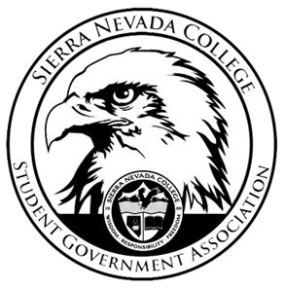
Sierra Nevada College Student Government Association

Tuesday, December 4, 2018
This is an agenda for the SGA Board at
8:00 AM in Campbell Friedman - SGA Office

Agenda

- Attendance
  - 8:00 am
- Reports
  - President
    - Surveillance cameras- a draft went through for $12,000.
    - $8,000 will be left over from the 2010 SGA Board’s Budget
  - Vice President
    - ICC Meeting on Thursday December 6th @6:30pm in the SGA office
  - Treasurer
    - Nothing to report
  - Director of Communications
    - Custom Ink is shipped Saana’s SGA clothing out yesterday
  - Sustainability Chair
    - The Green Council’s shed will be 10x10, placed over by the Exebio in the back parking lot.
    - Green Council will be having an event called, Ode to Muir Film at 7:30-9:30 pm on December 7th
  - Director of Events
    - Nothing to report
  - Senators
    - Nothing to report
  - Advisor
    - Will did not attend today’s meeting
- Guests & Proposals:
  - Clay Club
    - Clay Club is asking for $2,600 to go to a Clay Conference in Minneapolis
    - Request Funds- approved
- General Business
  - Debriefs & Updates:
  - Upcoming Events:
    - Holiday Study Break
      - December 5th 7:30-9pm
      - Free coffee, hot chocolate, and holiday treats
      - Gingerbread House Contest- Ty purchased the houses
        - Megan will come up with rules for the contest
      - Megan and Ty will go talk to Starbucks tomorrow to get hot water for Hot Chocolate mix.
      - Snowflake making
      - Ty will bring a speaker to play Christmas music
    - Spring Formal
      - Reserve the date: April 26th
      - If the 26th is not available, April 27th would be the alternative date.
    - Boral Friday’s
      - This event will be taking place next semester.
      - Every other week will switch from night skiing to day skiing.
  - SGA
    - Everyone on the board will send next semesters school schedule to Ty by the end of the week.
- Last Comments
- Adjournment
  - Close 8:45 am

SGA Executive Board: President- Ty Casey, Vice President- Drake Fiske, Treasurer- Luka Gobec
Director of Communications- Madalyn Johnson, Sustainability Chair-Lauren Rose, Director of Events- Saana Ahonen,
Faculty Advisor- Will Hoida

