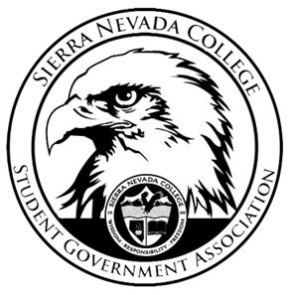
Sierra Nevada College Student Government Association

Thursday, April 11, 2019
This is an agenda for the SGA Board at
8:30 AM in Campbell Friedman - SGA Office

Minutes

- Attendance
  - Open 8:30 am
- Reports
  - President
    - Ty will organize a survey for the senior awards.
    - Everyone on the board will have to update their SGA position binders before next week.
  - Vice President
    - Dodgeball tournament was cancelled, due to lack of participation.
    - Drake was unable to attend today’s meeting.
  - Treasurer
    - Luka has started training Antonio on PR’s.
  - Director of Communications
    - Maddy will create a google form for the SGA Elections.
  - Sustainability Chair
    - Lauren will order the materials today/tomorrow for the composting shed.
  - Director of Events
    - Nothing to report
  - Senators
    - Nothing to report
  - Advisor
    - Will could not attend today’s meeting.
- Guests & Proposals:
- General Business
  - Debriefs & Updates:
    - Talent Show
      - This was the biggest turnout the talent show has ever had.
      - Next year, there will be a screening for the talent show as well as participants will receive money for participating.
  - Upcoming Events:
    - Spring Formal
      - Seniors will show up at 6:30 pm for the senior toast.
      - The band will play music while students are walking in.
      - Saturday, April 27th 7 to 11 pm.
      - Tickets will be sold Monday through Thursday next week.
      - Motion to approve $100 for Susan Gollery for driving the shuttle back and forth between the Hyatt and school.
        - Approved $100
      - Motion to approve $2,000 organizational necessities
        - Approved $2,000

    - Six Flags
      - Will would look into finding a bus for this event.
      - Friday, May 3rd
      - Ty will buy passes for Six Flags.
      - 42 Students will be allowed to go on this trip, signups will be available during the Spring Formal sign-ups in the Prime Library.
    - ICC Meeting
      - April 11th 6:30 pm in the SGA office
    - Barbeque
      - May 8th
      - Possible club volleyball tournament
      - IV will help out with the barbeque, we would buy the drinks and IV will buy the food.
  - SGA
- Last Comments
- Adjournment
  - Close 9:20 am

SGA Executive Board: President- Ty Casey, Vice President- Drake Fiske, Treasurer- Luka Gobec
Director of Communications- Madalyn Johnson, Sustainability Chair-Lauren Rose, Director of Events- Saana Ahonen,
Faculty Advisor- Will Hoida

