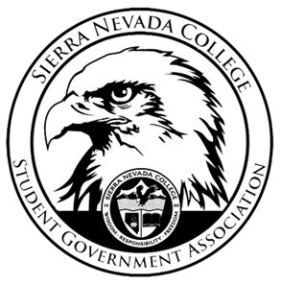
Sierra Nevada College Student Government Association

Thursday November 1, 2018
This is an agenda for the SGA Board at
8:00 AM in Campbell Friedman - SGA Office

Minutes

- Attendance
  - Open 8:03 am
- Reports
  - President
  - Vice President
  - Treasurer
  - Director of Communications
  - Sustainability Chair
    - Lauren and Celine presented to the sustainability class and more members joined the club.
  - Director of Events
  - Senators
    - Questions about Potty Press, on Wednesday ideas will be added, Thursday will be approval from Will, Nicole, and Saana, Friday the Press will be posted.
  - Advisor
- Guests & Proposals:
  - Creative Writing Club
    - Money request from AWP
    - Location Portland Oregon the students would take one of the vans to get to this conference.
    - Networking connecting with students
    - March 27TH-30TH
    - The club is going to have 2 fundraisers.
- General Business
  - Debriefs & Updates:
    - Halloween Dance
      - The Halloween Dance was a successful event
      - Next year SGA will be more aware of the sport schedules.
      - Different advertising Text
        - A dress code will be at the next SGA event.
    - Club Video Contest
      - ICC meeting tonight at 6:30 pm in SGA office.
      - 4 videos were summited
      - The 3 best videos will be shown at the student forum.
  - Upcoming Events:
    - Mammoth
      - November pre-trip meeting 6th at 7pm TCES 106
      - Leaving by 5:15 on November 9th outside of Patterson.
      - Tell student who have not come to the volunteer work will have to voluntary at future SGA events.
    - Thanksgiving Dinner
      - Saana will talk to Nicole about decorations
      - November 15th 5-7pm
      - Events meeting
      - Flyer done
      - Facebook and Instagram promotion
      - Free for students.
    - Holiday Party
      - December 5th
      - This event is very similar to the Grub Hub Study Break
    - Dorm clothing swap
      - Talk to Jenna and Joao
      - Let students know to donate your clothes
  - SGA
- Last Comments
  - Meeting Times
    - 8 am on Thursdays
    - Events and Financial meeting on Monday at 4 pm.
- Adjournment
  - Close 9:33 am

SGA Executive Board: President- Ty Casey, Vice President- Drake Fiske, Treasurer- Luka Gobec
Director of Communications- Madalyn Johnson, Sustainability Chair-Lauren Rose, Director of Events- Saana Ahonen,
Faculty Advisor- Will Hoida

