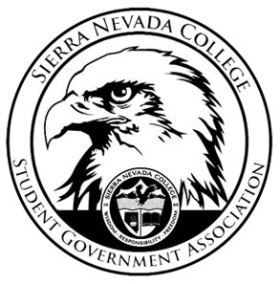
Sierra Nevada College Student Government Association

Monday, March 4, 2019
This is an agenda for the SGA Board at
8:30 AM in Campbell Friedman - SGA Office

Agenda

- Attendance
  - Open 8:30 am
- Reports
  - President
    - Could not attend meeting
    - Ty will send out evaluations soon
  - Vice President
    - Drake emailed Shane from the Rec Center, to figure out a day for the club dodgeball event.
  - Treasurer
    - Could not attend meeting
  - Director of Communications
    - Nothing to report
  - Sustainability Chair
    - Could not attend meet
  - Director of Events
    - Could not attend meeting
  - Senators
    - Nothing to report
  - Advisor
    - Will is helping Lauren make the composing happen.
- Guests & Proposals:
  - Climbing Club
    - Requesting money for t-shirts and a climbing day open to all student in South Lake.
  - Golf Club
- General Business
  - Debriefs & Updates:
  - Upcoming Events:
    - Students Q&A
      - Thursday, March 7th 6pm
      - Free Pizza
      - TCES 106
    - Northstar Ice Skating
      - Friday, March 8th 2-6 pm
    - Spring Formal
      - The chaperons have been invited.
      - Saturday, April 27th

  - SGA
    - Events Meeting
      - Wednesday at 5:30 pm
- Last Comments
  - Closed 8:51 am
- Adjournment

SGA Executive Board: President- Ty Casey, Vice President- Drake Fiske, Treasurer- Luka Gobec
Director of Communications- Madalyn Johnson, Sustainability Chair-Lauren Rose, Director of Events- Saana Ahonen,
Faculty Advisor- Will Hoida

